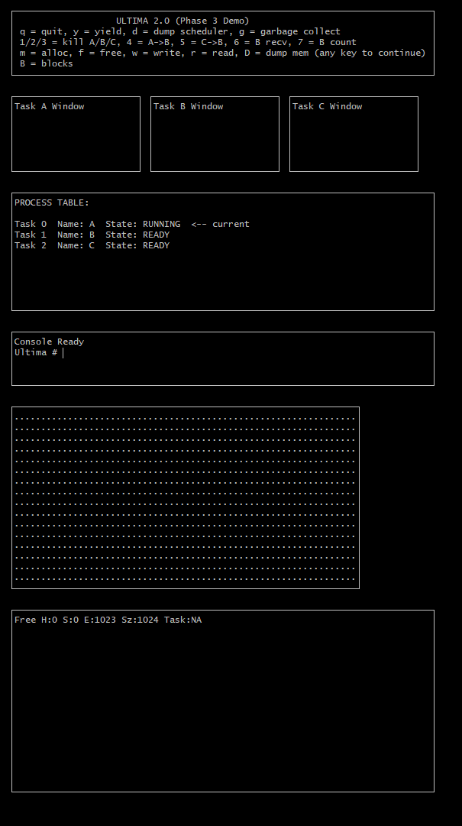
Default State of the OS.

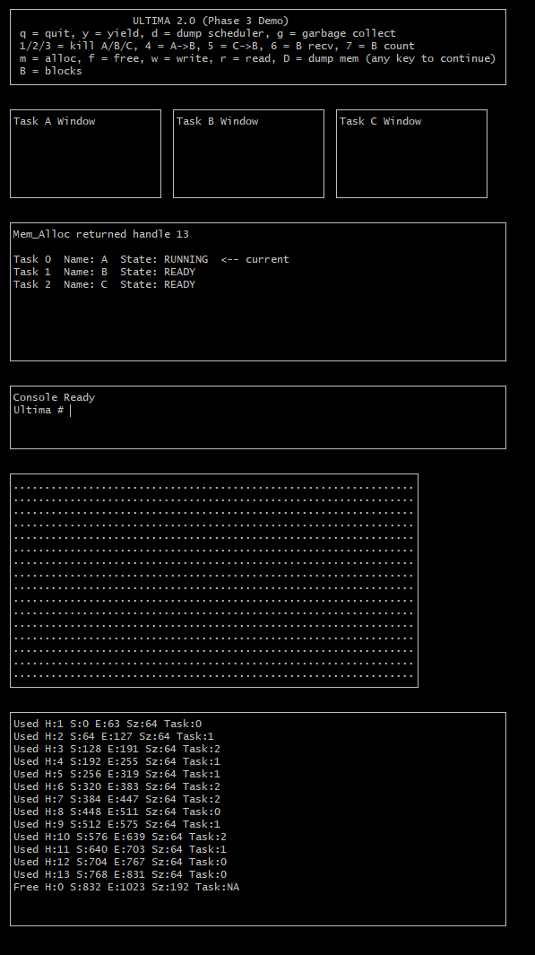
Several Blocks have been acquired by the tasks. This demonstrates that the Mem_Alloc function is working properly.
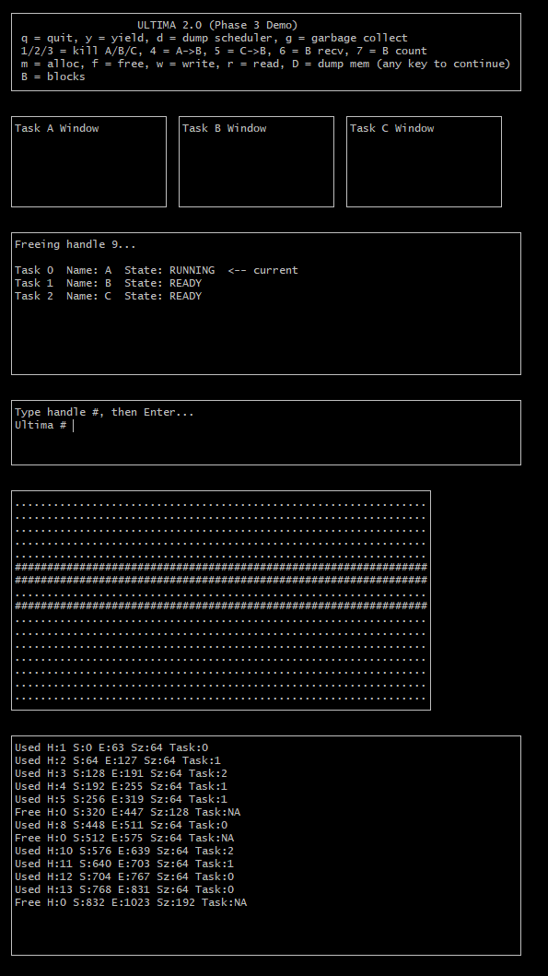
Memory state after freeing block handles 6, 7 and 9. Demonstrates the Mem_Free and Coalesce Functions are working properly. Memory blocks 6 and 7 have been combined into one continuous block.
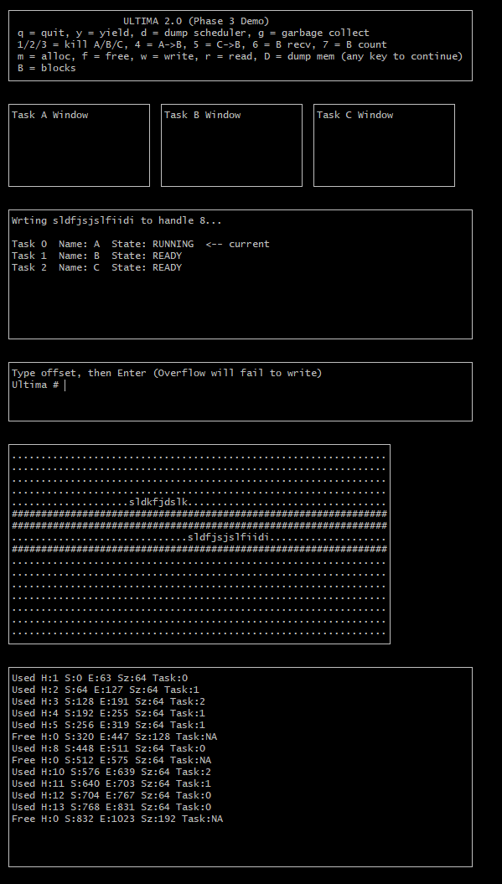
Data written to block handles 5 and 8, demonstrating Mem_Write function works.

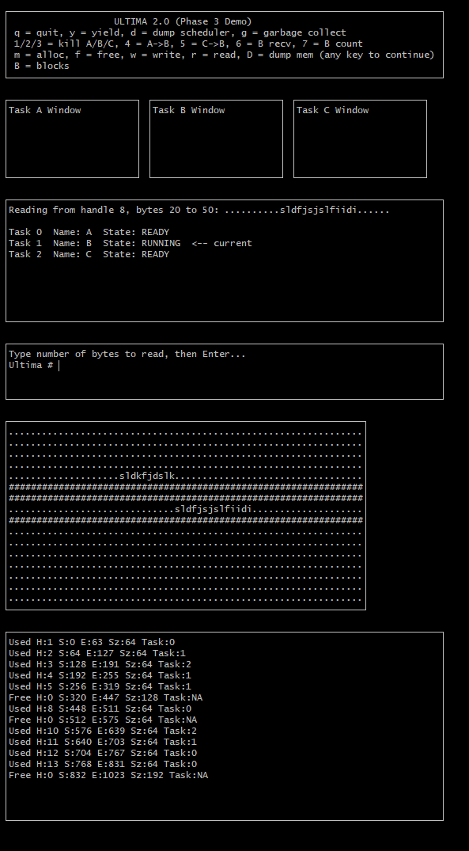
Here 30 bytes have been read from memory block 8, showing that the Mem_Read function works properly.

